

From Overextended to Supported: Designing Environments that Work for Educators and Students
Introduction to the Learning Landscape
The Learning Landscape is three core conditions that shape what is possible for learning, growth, and well-being. Our core belief is that conditions shape what is possible.
- Environment - Creating environments that do more of the work reduce reliance on constant educator intervention and support greater student independence
- Relational Dynamics - Recognizing how nervous systems influence one another and navigating relationships through this lens to shift patterns that keep educators and students stuck and create new possibilities.
- Educator and Student Support - Providing support that adapts to the individual, their shifting capacity, and the context helps educators and students move through challenges as they occur.

What is the Environment?
Environment isn't just the room, it’s everything a person encounters and experiences in a moment: what's physically around them (Physical Space), how their nervous system is taking it in (Nervous System Experience), and what's available to help them move through it (Access)

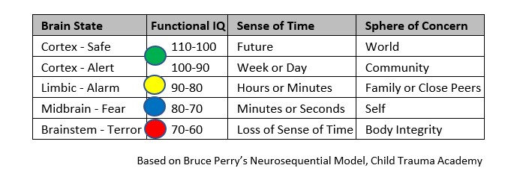
The Foundational Science to make this make sense
The Brain-
- Brain States - What can I process?
- Stress can get us stuck in lower states

The Nervous System-
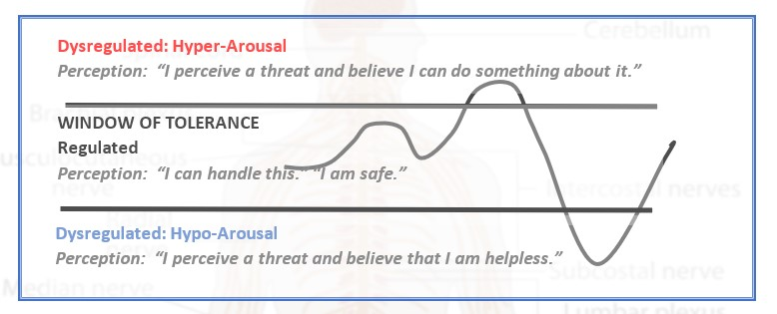
- States of arousal - Regulated, hypoaroused, hyperaroused
  - Perception determines state of arousal
  - When outside my window of tolerance, I have less options and choices
  - We are made to pulse it’s only an issue when we get stuck
- Energy goes to different parts of our body.
- Windows of tolerance are not static

Behavior and Regulation-
- Shutting down behaviors can increase the chances of an explosion or collapse
- Behaviors are attempts at regulation and students are asking the question what do I do with this energy?

Applying this science to create environments that do more of the work:
Broadening Our Understanding of the Experience

Physical Space -What's here. The people, things, and setup physically around a student right now.
- Space and layout - open space vs boundaries/containment (over or around them)
- People and objects
- Proximity and crowding
- Lighting, temperature, sound, texture, and movement
- Am I being required to sit in a certain way or in a certain space
- Space to move, pause, or step away only at certain times

Nervous System Experience - What's happening inside. A student's nervous system experience of what's here — what they're taking in, and how it's landing.
- Am I regulated, hypoaroused or hyperaroused?
- How big is my window of tolerance?
- What and how much can I process?
- Are any of my sensory channels being flooded?

Notice external clues that may provide us with information about arousal states.

Access - What's available. The tools, options, and resources readily available right now, to move through what they're experiencing.
- Tools and resources within my reach and/or that I can access independently
- How is my state impacting my access?
- Can my body move?
- Can I opt out?
- Do I have a way to communicate my needs if I am able?

Notice external clues that may provide us with information about what they can access

Scaffolding Students’ Awareness and Understanding
- Create opportunities for students to notice internal and external clues.
- Help students make sense of what they notice.
- Strengthen interoceptive awareness. Interception is our 8th sensory system and gives us information about our bodies.
- Explore Braindrops™ Framework- a way to communicate about the energy moving through our bodies

Facilitating Communication, Exploration, and Access
- Provide different ways for students to communicate about their nervous system experiences.
- Create opportunities for students to explore different ways of regulating and discover what works for them given what they are experiencing and the context of the moment.
- Make relevant forms of support easier to identify and access.
- Braindrops™ -
- Match or Mismatch™ – a tool for recognizing where the energy is going in your body and identifying if the way it is showing up is a match or mismatch for the current moment.
- Learning Tools Protocol™ - exploring tool vs toy, providing practice time with gentle redirection for immediate feedback, allowing students to decide what tools work for them.

Concepts and Tools
Concepts & Tools | What It Provides
Arousal States | A foundation for recognizing that energy is moving through the body and prompting action.
Braindrops™ | A shared framework and language for communicating about nervous-system experiences.
Interoception | The capacity students develop as they learn to notice and make sense of physical sensations.
Match or mismatch™ | A framework for exploring what works for the student within their current experience.
Learning Tools protocol™ | A process for developing self-awareness, practicing different ways of regulating, and discovering what is effective for the student and accessible when needed.

Tying it Together

